Big Mountain Resort Price Analysis Report
Sepehr Hajibikloo
November 2023
Data Sourced from: Springboard Data Science Career Track
Introduction:
Big Mountain Resort has recently installed an additional chair lift to help increase the distribution of visitors across the mountain. This additional chair increases their operating costs by $1,540,000 this season. The resort's pricing strategy has been to charge a premium above the average price of resorts in its market segment. They know there are limitations to this approach. There's a suspicion that Big Mountain is not capitalizing on its facilities as much as it could.
The Big Mountain resort is a ski resort located in Montana, 350,000 people visit every year to ski or snowboard the big mountain. They recent addition of chair lift increasing their operation cost to $1.54M per season. Need to find a way to reduce the operation cost, and project the revenue of the season based on the reduced operation cost.
Data Wrangling:
The first values inspected were the Adult Weekend vs Adult Weekday prices, was it actually advantageous to have a different price for the weekend? Most states had the same price for both, as seen by the chart below:
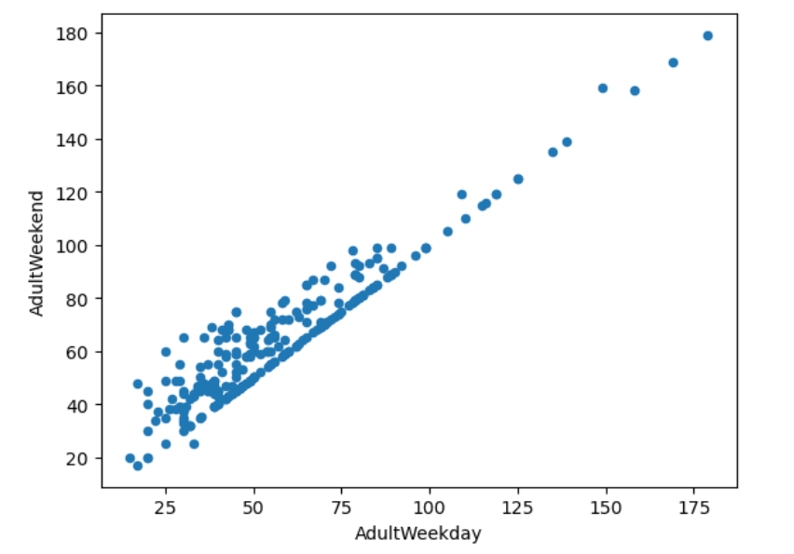
Adult Weekend had several missing values. Because of this, the Adult Weekend column was removed. In addition to Adult Weekend, the fastEight column was dropped because value of its values were null and the other half were mostly 0. Besides those two big ones, there were some smaller columns that had to be dropped and a lot of missing values that had to be taken care of. Once this was finished, we were left with 277 of the original 330 rows.
Exploratory Data Analysis:
In order to find trends, patterns, and actionable insights in the data, we need to explore and find these patterns. The first pattern explored was the relationship between the total number of resorts by population vs total number of resorts by area. This didn’t yield much usable information for Big Mountain Resort, but it did clear up some initial thoughts. The next relationship I wanted to look into was the relationship between the components like vertical drop, years open, or skiable areas versus the price in each state. This required a Principal Cumulative Analysis (PCA), which showed that the first two components account for 75% of the variance, and the first four account for 95%. Focusing 3 on just the two components, I scaled the data and added the average ticket price to a scatter plot. I needed to see a clearer relationship between price and components, so instead I created a heatmap to better visualize the relationship between each feature.
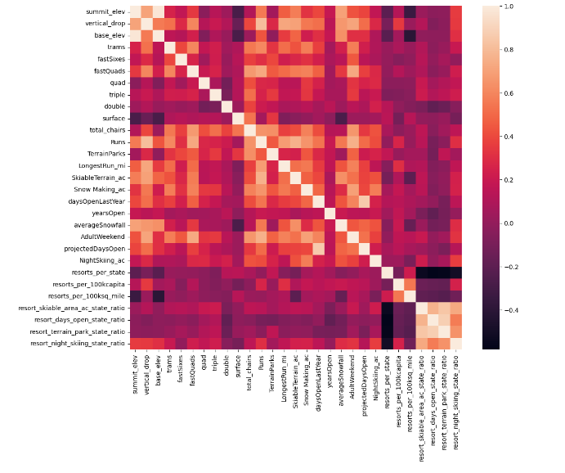
Focusing on the relationships in the “Adult Weekend” row shows that there is clear positive correlation associated strongly with fastQuads, Runs, SnowMaking_Ac, and resort_night_skiing_state_ratio. Now we can use these features to build a model that can determine a new data-based ticket price.
Pre-Processing and Training Data:
After identifying the four categories with the strongest correlation to price, the first step was to take an initial average as a “best guess” for pricing. This resulted in $83.81 initially which was the baseline I used to compare other prices to moving forward. Mean wasn’t the best for this because our Absolute Error was off by around $19, much too large for a price like this. Instead, I performed a regression using the median between results. The Mean Absolute Error was only off by $9 this time, but I knew this could still be improved. I also decided to create a data pipeline in order to efficiently produce identical results to make comparisons easier. The next regression was based on a Random Forest Model which helped identify that imputing the median value helps with the MAE of our four components. In addition to our four components, during the analysis I found that vertical drop also plays a big role in determining ticket price. Once this new component was added to the Random Forest Model, the Mean Absolute error was down to around $1 which was an acceptable amount of variability.
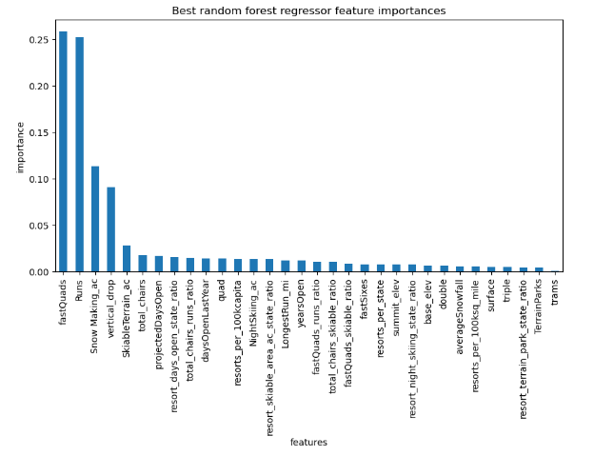
Modeling:
At this point I have picked the top components and a method of regression. I can use these together to create a model that actually gives us a data-based ticket price. To make the model as accurate as possible I boosted the number of components to eight by adding total_chairs, LongestRun_mi, trams, and vertical_drop to the list. To determine a fair price, I needed to see where Big Mountain Resort (represented by the dashed red line) ranked in these categories. - Vertical Drop - Total Chairs 6 - Fast Quads - Longest Run - Number of Trams - Number of Runs 7 - Area Covered by Snow Makers - Skiable Area.
Vertical Drop
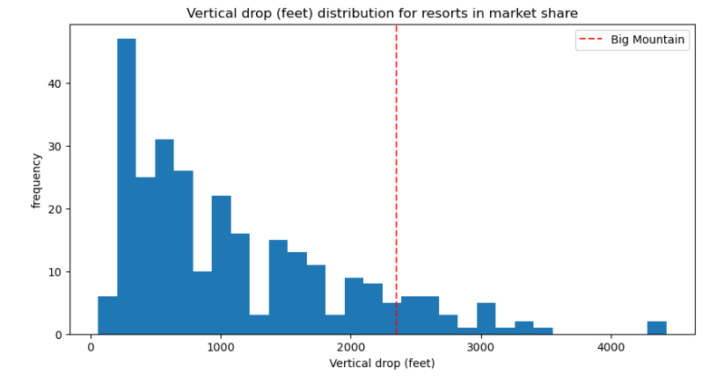
Total Chairs
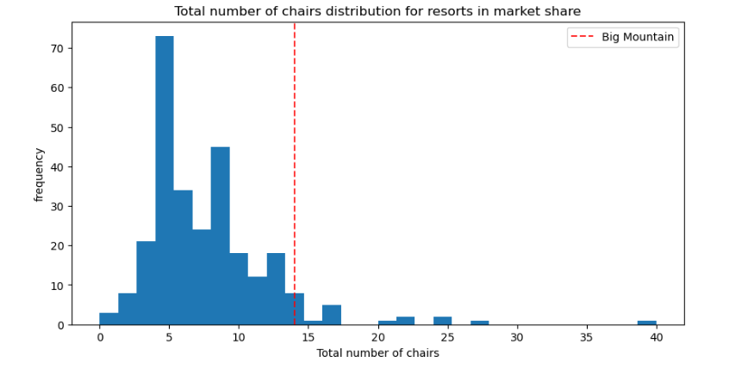
Fast Quads
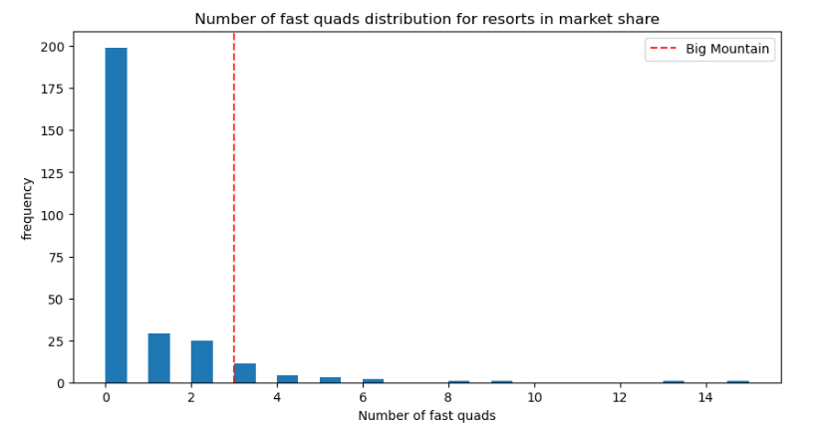
Longest Run
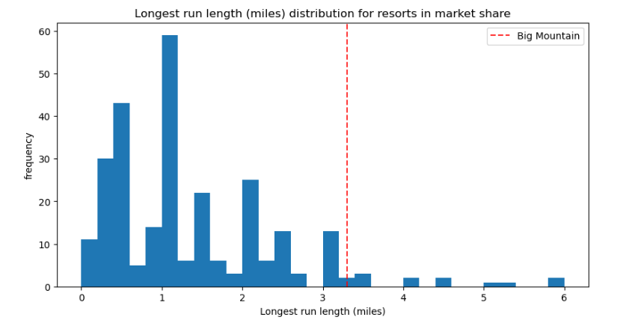
Number of Trams
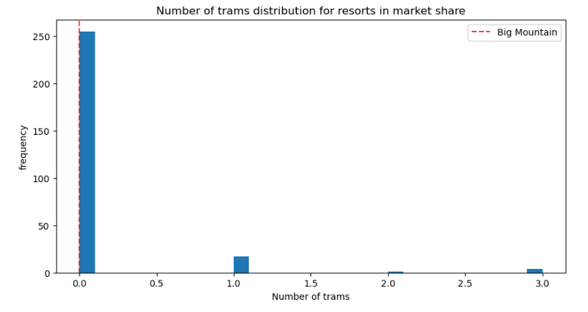
Area Covered by Snow Makers
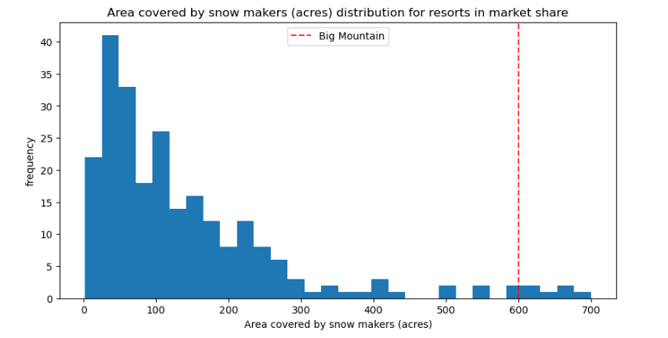
Skiable Area
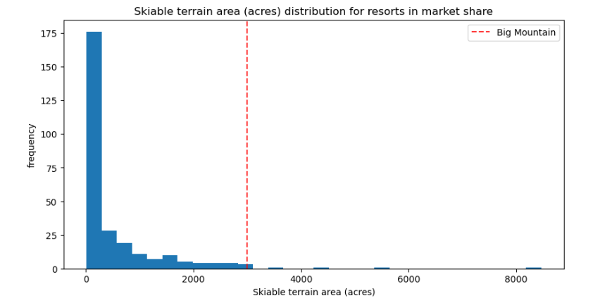
As you can see, Big Mountain Resort either ranks high or is well above the average in each category. With the exception of trams which most resorts don’t have anyway. All this shows us that Big Mountain Resort is an exceptional resort with many great facilities, and the price should reflect that. With that we get a modelled price of $96.62, which is well above their current price of $81.00.
Conclusion:
Big Mountain Resort is currently charging very little for all the services they are offering. According to this analysis, they excel at seven of the eight most important, price-determining features and therefore should raise their ticket price by at least $10.00. In addition to this, Big Mountain Resort can also save a lot of money by not having all of their runs open at once. While they do get 350,000 visitors per year, day-to-day not each run is being fully utilized and this can be very expensive. According to a predictive analysis based on the Random Forest Model (shown below), Big Mountain Resort can keep up to 5 runs closed without a huge drop in revenue.

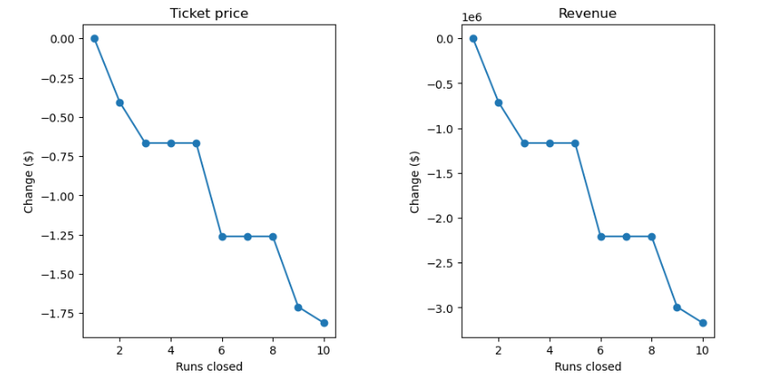

With all of this in mind, I think we now have two very simple ways to keep Big Mountain Resort running while still providing the numerous amenities it has to offer to its customers. This data and model are good for now, however in the future I can see improvements being made particularly in the category of prices that other resorts are charging. The data fails to account for resorts that might be undercharging their tickets because they have expensive rental or hotel fees, we only have the ticket price. Once this data is acquired however, the model can only get better from here. I see a lot of opportunity for growth at Big Mountain Resort and I hope that the results of this analysis can be implemented so that the resort can stay open for many years to come.

